P.K. INNOVATIVES

Internship

DAY-1 REPORT

Day1 adobe xd installation was done and based on

The videos the project starts

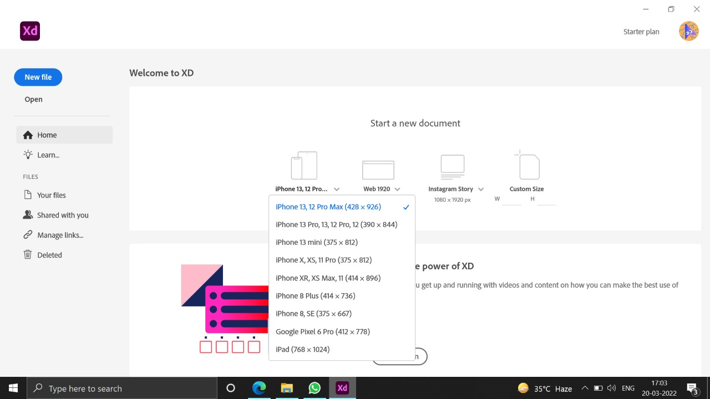

The project name which I have given to the

Design is Medi-City which will be based on

The medical facilities in the city near by the

User.and pharmacies near by them.

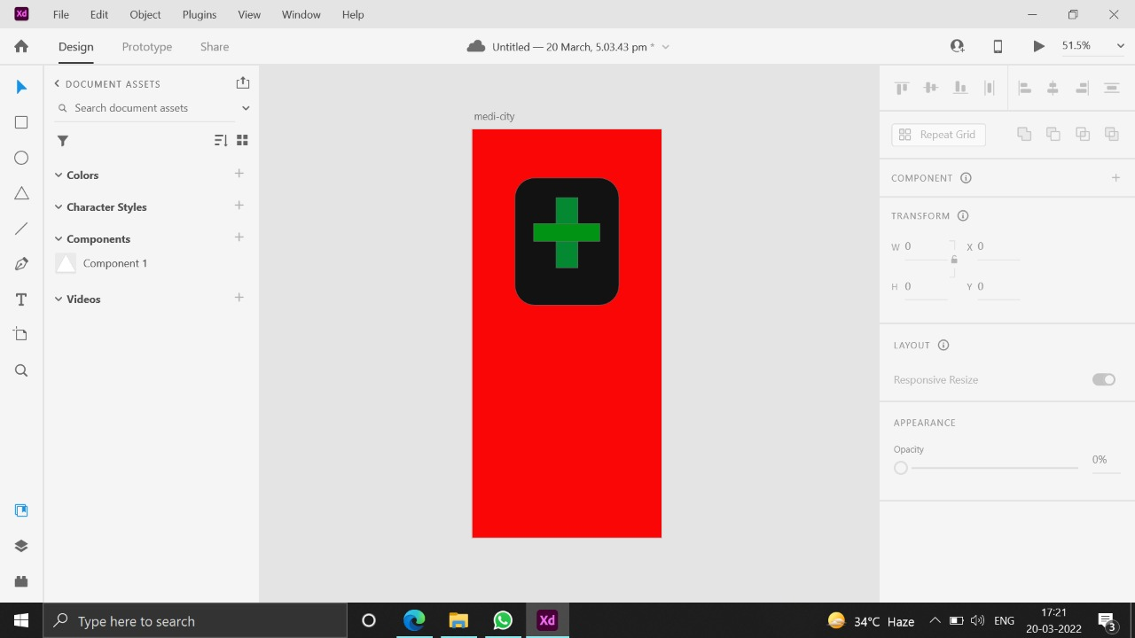

This design also includes the health checkup

Which can be used by the user itself.which is

An highlight which I added to this project

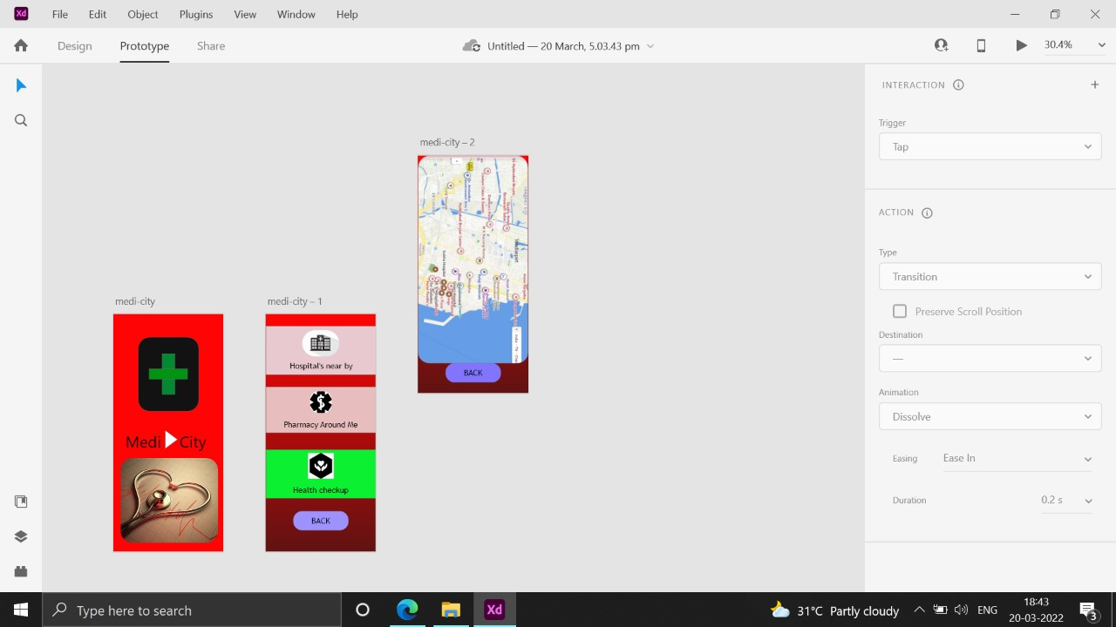

End of day-1